**Linux Basic**



Linux Installation with Automatic Partitioning ( RHEL-6 )

1. Insert RHEL-6 DVD (or) bootable pen drive in PC.
2. Go to BIOS setup by pressing f2 or del or f10 key -> boot ->

Make First boot device = DVD or Removal drive

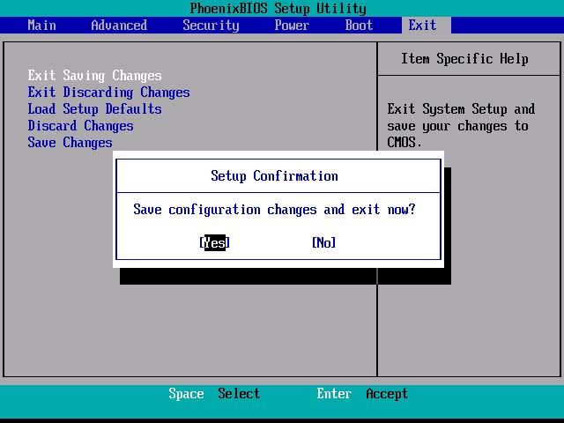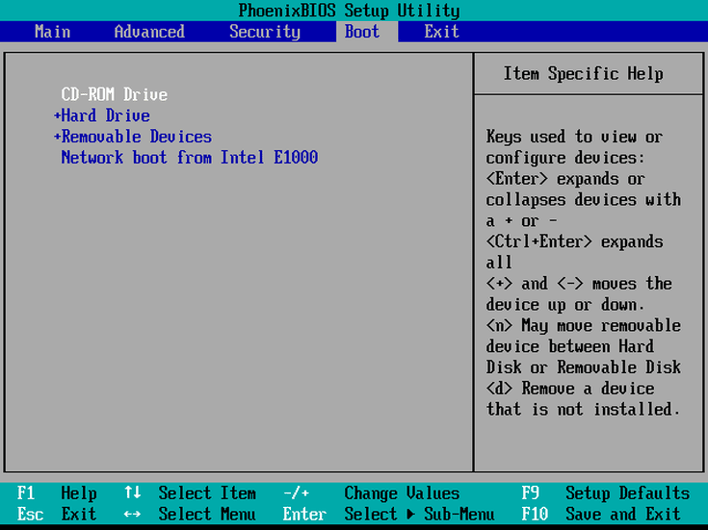Press f10 to save and exit --Press Enter---System will restart

3) After Restart RHEL menu appears then select Install or Upgrade an existing system-----skip—next – next - next – select () Basic Storage device

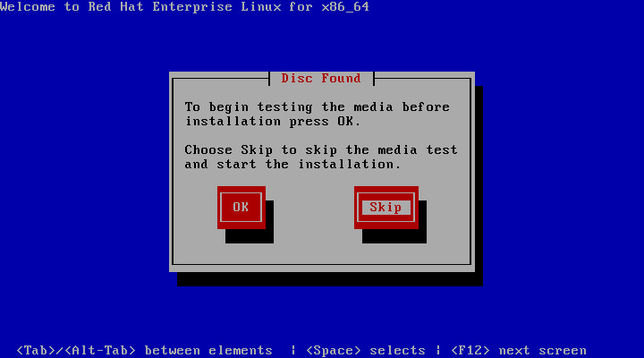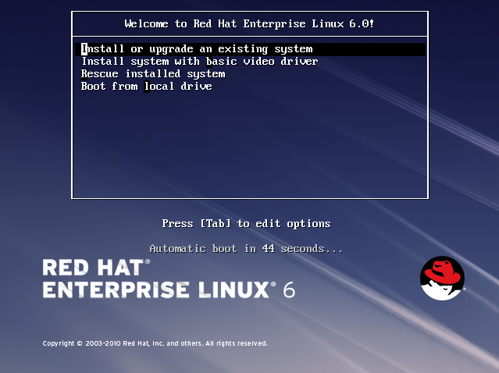

-next- yes discard any data- Type hostname(PC name) –next-

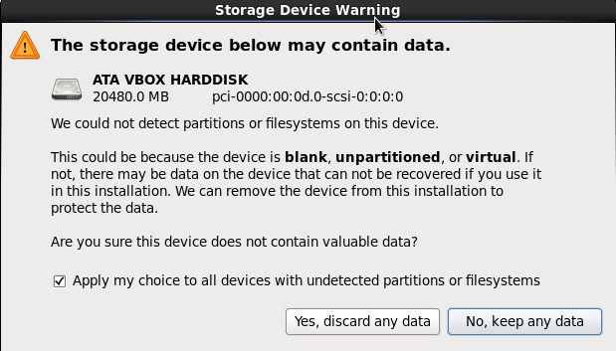

Set time zone () Asia/Kolkata –next- type root password—next-select () use all space

--next- format- write any changes to disk-next—select () Desktop –next-..............................................................................................................Reboot

Linux Installation with automatic Partitioning ( RHEL-7)

1. Insert RHEL-6 dvd (or) bootable pen drive in pc.
2. Go to BIOS setup by pressing f2 or del or f10 key -> boot ->

Make First boot device=DVD or Removal drive - press f10 to save and exit

--Press Enter---System will restart

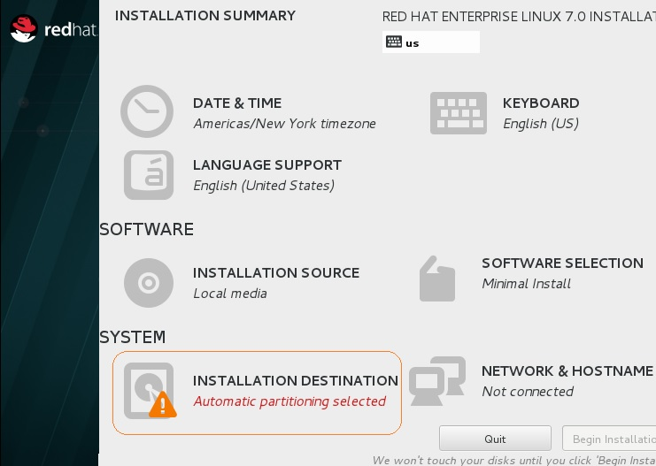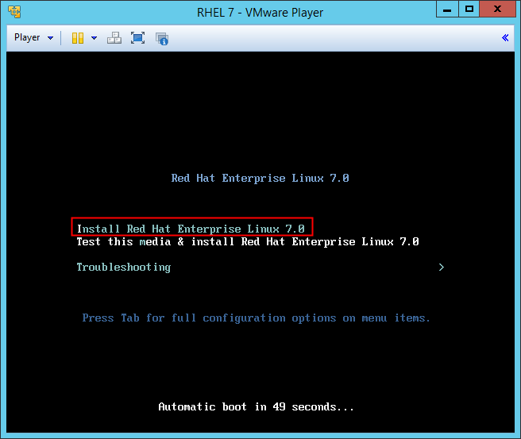 3) After Restart RHEL menu appears then select ..Install RHEL 7.0 -----continue-----

a) Select date and Time --- Asia/Kolkata --Done

b) Software Selection - select Server with GUI—done

c) Installation destination ----select Configure automatic partitioning—done

d) Configure Hostname ---Type Hostname (PC name) –done

---Begin installation-------------

Here we can set root password and can create new users also

**INTRODUTION TO LINUX**

BRIEF INTRODUCTION OF UNIX:

UNIX- UNIPLEXED INFORMATION COMPUTING SYSTEM.

* + It is developed in 1969 by **Kem Thomson** and **Dennis Ritchie.**
  + It is written in c language.
  + It is open source operating system.

BRIEF INTRODUCTION OF LINUX AND ITS DISTRIBUTIONS:

1. LINUX:
   * + It is developed by **Linus Torvalds**.
     + **Linux** were publicly released later that **year** (1991)
     + Based on UNIX OS, C language and Assembly level language.
     + It is open source Operating system.
2. DISTRIBUTIONS:

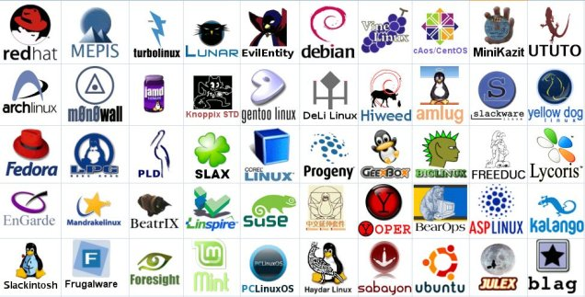 Red hat Linux, Fedora, Cent OS, Mandriva, Debian, Slackware Linux, Scientific Linux, Arch Linux, Free Linux, Back track –kali Linux, Open Source.

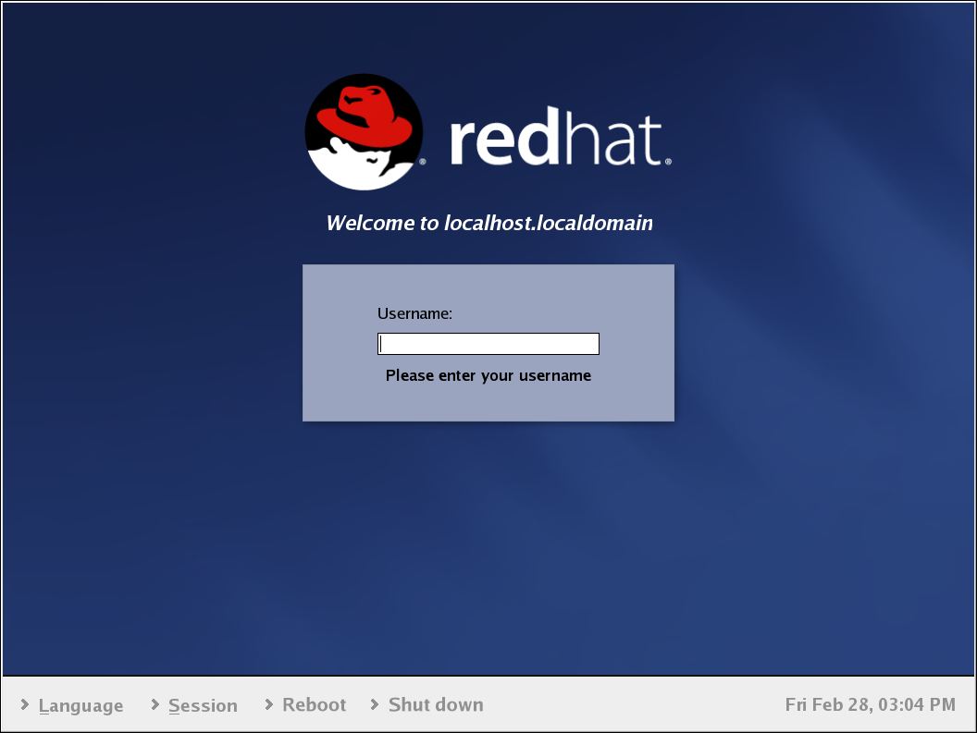

* RED HAT VERSIONS:
* Red hat Linux 1.1
* Red hat Linux 2.0
* Red hat Linux 3.0
* Red hat Linux 4.0
* Red hat Linux 5.0
* Red hat Linux 6.0
* Red hat Linux 7.0
* Red hat Linux 8.0
* Red hat Linux 9.0
* RED HAT ENTERPRISE LINUX:
  + - Red Hat Enterprise Linux 2.1
    - Red Hat Enterprise Linux 3.0
    - Red Hat Enterprise Linux.0
    - Red Hat Enterprise Linux 5.0
    - Red Hat Enterprise Linux 6.0
    - Red Hat Enterprise Linux 7.0, 7.1, 7.3
* DIRECTORY STRUCTURE OF LINUX:

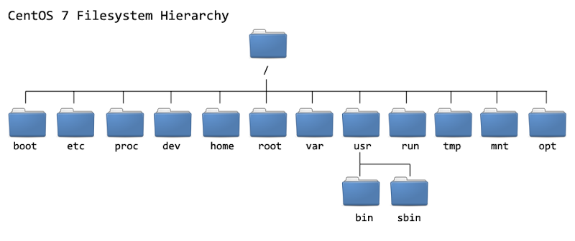

/bin/ - Essential user command binaries

/boot/ - Static files of the boot loader

/dev/ - Device files

/etc/ - Host-specific system configuration (secure directories)

/home/ - User home directories

/lib/ - Essential shared libraries and kernel modules

/media/ - Mount point from removable disk

/mnt/ - Mount point for a temporarily mounted file system

/opt/ - Add-on-applications software packages

/sbin/ - System binaries

/srv/ - Data for service provided by this system

/tmp/ - Temporary files

/usr/ - Multi-user utilities and apps

/var/ - Variable files

/root/ - Home directory for the root user

/proc/ - Virtual file system documenting kernel and process status as text files.

* DIFFERENT TERMINALS IN LINUX:
  + CTRL+ALT+F1 ---GUI Mode
  + CTRL+ALT+F2 ---CUI Mode
  + 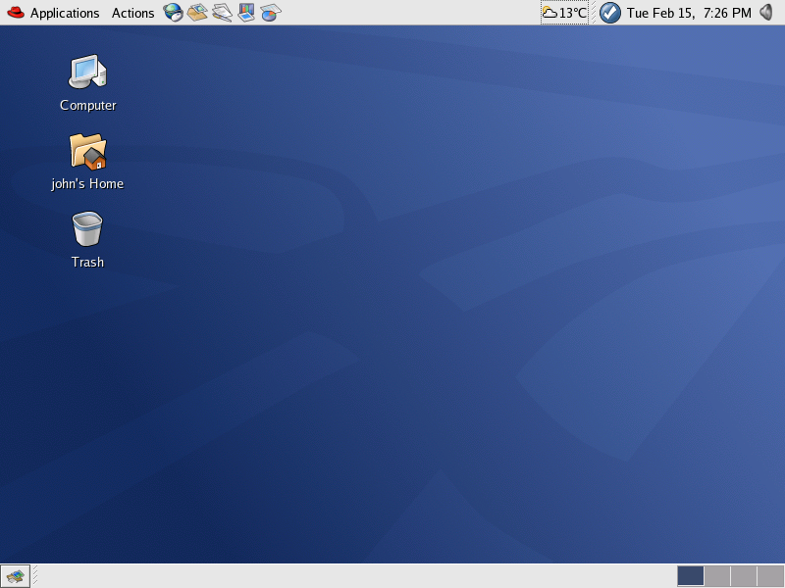CTRL+ALT+F3--- CUI Mode
  + CTRL+ALT+F4--- CUI Mode
  + CTRL+ALT+F5--- CUI Mode
  + CTRL+ALT+F6--- CUI Mode
  + CTRL+ALT+F7--- GUI Mode

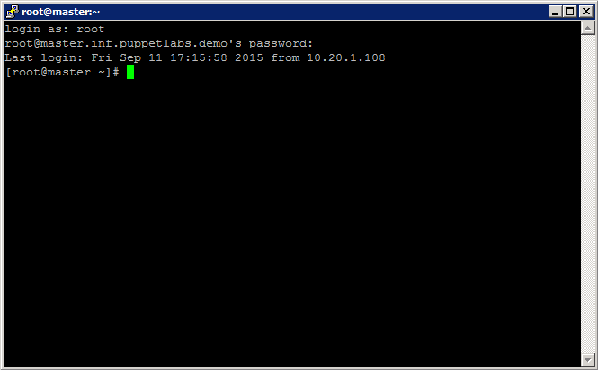

* DIFFERENT DESKTOP:
* ubantoUbuntu's Unity desktop with Dash open.
* The **GNOME** desktop in Fedora Workstation.
* **KDE** in kool desktop environment.
* Linux Mint with the Cinnamon desktop.
* Linux Mint with the MATE desktop.
* Lubuntu with the LXDE desktop.
* Xubuntu with the XFCE desktop.

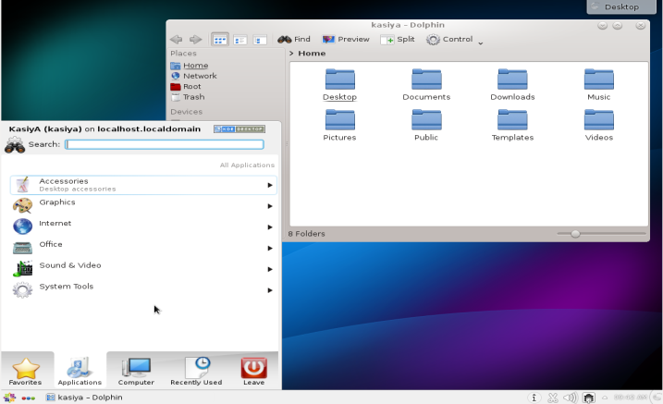 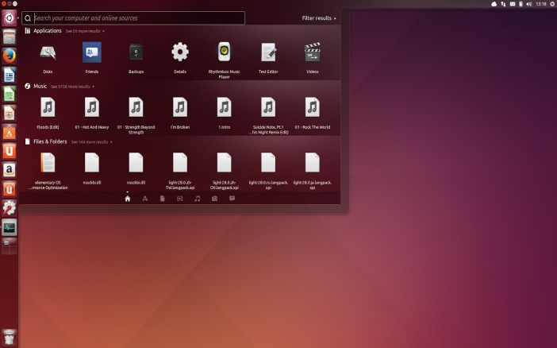

* USER ACCOUNT TYPES:

Three types of user accounts:

* Administrative (Root).
* Regular.
* Service.

**Administrative (Root):** The Linux administrative root account is automatically created when you install Linux, and it has administrative privileges for all services on Linux Operating System. The root account is also known as super user

**Regular:** Regular users have the necessary privileges to perform standard tasks on a Linux computer such as running word processors, databases, and Web browsers. They can store files in their own home directories. Since regular users do not normally have administrative privileges, they cannot accidentally delete critical operating system configuration files.

**Service:** Services such as Apache, Squid, mail, games, and printing have their own individual service accounts. These accounts exist to allow each of these services to interact with your computer.

# Command uname: print system information such as computer and kernel name or CPU info

## Operating system

**uname -o** prints the name of the operation system, for example GNU/Linux

## Host name

**uname -n** prints the host name.

## Kernel name and release

**uname -s** prints the name of the kernel, for example Linux.

**uname -r** prints the [kernel release](https://renenyffenegger.ch/notes/Linux/kernel/release), for example 4.12.8-2-ARCH.

## CPU and hardware

**uname -p** prints the *processor type*, for example x86_64.

**uname -m** prints the *machine hardware name* (architecture), for example x86_64. This is the same output that also [arch](https://renenyffenegger.ch/notes/Linux/shell/commands/arch) prints.

**uname -i** prints the *hardware platform*, for example x86_64.

uname -p and uname -m should get the same output. uname -i is smaller or equal to the other two.

Use **[lscpu](https://renenyffenegger.ch/notes/Linux/shell/commands/lscpu)**to display information about the [CPU](https://renenyffenegger.ch/notes/hardware/CPU) architecture.

## All information

All information can be printed at once with uname -a. It prints a string like

Linux L1 4.4.0-24-generic #43-Ubuntu SMP Wed Jun 8 19:27:37 UTC 2016 x86_64 x86_64 x86_64 GNU/Linux

**BASIC COMMANDS IN LINUX ,**

BASIC COMMANDS:

#pwd : Present working directory ( To check current cursor location)

#ls : So the content of current directory.

#cd / : To come in root level.

#cd ~ : To come to user level.

#cd .. : come one step back.

#mkdir dirname : To create a directory/folder.

#cd dirname : To go to inside the directory.

#mkdir dir1 dir2 dir3 : To create multiple dir at a time

Listing or showing content

#ls –a : To show all

# ls –a /* - to show / contend with subdirectory

#ls –r : To show all but in reverse alphabetic order

#ls -i filename/dirname : to show inode number

# ls -l filename/dirname : to show associated permissions

# ls -t filename/dirname : to show which created first( based on time)

# ls [dk]* : to show only dir/file which initial is d and k

# ls [d-k]* : to show all dir/file between d and k

# ls [!dk]* : to show all dir/file except which initial is d and k

Working with File

#touch filename : To create empty file.

#cat >filename : To create a file.

...................

.................... Write ur text normally

Now press “ ctrl+d “ - To save.

#cat filename : To see the file contents.

#more filename : Showing content of file one screen at a time ( Sequentially)

Eg: #more /root/install.log

#less filename : Showing content of file one screen at a time ( in reverse order)

# head filename : Showing content of top portion only

# tail filename : Showing content of bottom portion only

# cat file1; cat fil2; cat file3 : To see the content of multiple file at a time.

# echo “ tiger” > file1 : to insert content in a file without opening it.

# cat file1 file2 > file3 : To combine content of two file and insert in new file

#rm filename : To remove a file.

#rm –f filename : To remove a file without asking permissions.

#cp : To copy the file and dir.

#cp source-path/file-name dest-path/ : To copy and paste for files

# mv source-path/file-name dest-path/ : To cut and paste for files

# mv old-file-name new-file-name : To rename the file/folder name.

#sort : to show content of file in sorted form ( only for viewing)

Eg:

# sort filename : to show from a-----z

#sort -r filename : to show from z-----a

# sort file1 file 2 : show sorting content from both file

# sort file1 >sort.txt : saving the sorted result in a new file.

Comparing

|  |  |
| --- | --- |
| Cmp | diff |
| 1. Used for files only 2. #cmp file1 file2 3. Show the differences only | 1. Used for files as well as dir also 2. #diff file1 file2   #diff dir1 dir2   1. #show both files or dir content in one page |

#rm –r dirname : To remove a directory/folder.

#rm –rf dirname : To remove a directory/folder without asking confirmaton

#cp –r [dir-source-path] [dir-destination-path] : To copy and paste for dir

#mv –r [dir-source-path] [dir-destination-path] : To cut and paste for dir

#su (super user) : To switch normal user to identity mode

#clear : To clear the screen.

#eject : To eject secondary device.( cd/dvd)

#eject –t : To insert secondary device.( cd/dvd)

#history : To see the used commands history.

#history –c : To delete history

# history > /root/history.txt : to save history result in a file

#wc : To see how many characters/words/lines are used in file.

# wc -c file-name

# wc -w file-name

# wc -l file-name

#cal : It shows the calendar

#cal month-no(1-12) year-no(1-9999)

# cal 1947 or cal 01 2017 or cal 08 1520

#whoami : Shows the logged on user

#date : To show the date in different ways.

: date +%a or date +%c or date +%d etc

# bc : calculator work

Need to get help of any command

# whatis command-name

# command-name --help

# man command-name

# whereis command-name

To Cancel running process

Press ctrl+c or q

Aliasing

Creating nick name of command

# alias m=mkdir --🡪 #m india : india folder will be created

#alias cd=”cd /root/Desktop/Data/”  
#alias kk=” rm -f /india/song/*.mp3”

#unalias -a : to unalias all

# unalias m : to unalias only m

Checking running process

#ps -A

#top

#chkconfig --list

#kill process-id : To delete the process.

#killall : To delete all process

To shutdown and restart

|  |  |
| --- | --- |
| Restart | Shutdown |
| a)# init 6  b)press ctrl+alt+del  c) #reboot | 1. #init 0 2. # halt now 3. # shutdown –h 10 ( to shutdown after 10 min)   Q- How to cancel running shutdown process  Ans – Log on through other terminal and type  # shutdown -c |

Finding Something

# find filename : To find something within the dir

#locate filename : To find something in entire OS

Note: Sometime locate command do not show anything then use # updatedb and use locate command again

#grep “string” filename : to find availability of word in particular file

Eg: grep “traceroute” /root/install.log

#whereis command-name : To check the script file location

Egg : # whereis date or #whereis mkdir or # whereis ls

Checking Disk size

#du dir/filename : To show the disk usage.

#df dir : To show the disk usage as well as available space.

#free dir name/ : To show the disk/available/free space.

Mounting and Ejecting

#mount /dev/sdb /mnt : To mount or link any external device.

#umount /dev/sdb : To eject the mounted device.

# fdisk –l -> to know all storage device

# hostname : To check Computer-name

#ping remote-pc-IP/www.google.com : Checking availability of remote mode.

#nslookup www.google.com : To know the IP address of google.

#telnet remote-pc : To take control of remote in command.

#passwd : To set password.

#logout : To logout the pc.

#tput : To change the terminal font and background color.

#tput setab (0-7) : changing background

#tput setaf (0-7) : changing font

# tput reset : to reset all colours

FILE EDITING IN LINUX:

1. vi 2) vim 3) emacs 4) pico 5) nano 6) lime

For eg:

#vi filename

[press i]

Write your text normally

[press esc]

:x (or) :wq -> to save and exit.

:q! -> Exit without saving.

COLOR INDICATION

1. Green – Executable files.
2. Blue – Directory.
3. White – File.
4. Cyan – Symbolic link.
5. Yellow – Pipe.
6. Magenta – Socket.
7. Bold yellow foreground, with black ground – Block device driver.
8. Blinking bold white red backround – Missing link.

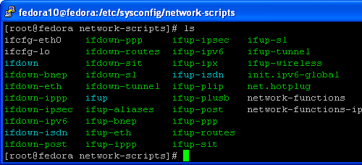

**HARD LINK AND SOFTLINK:**

* HARD LINK:
* Two files are linked with each other, if we do changes in one file, the same changes can be seen in other file.
* The inode number of both file will be same.
* We cannot create a Hard Link for a directory.
* If one file is deleted, there is no effect in other file.
* We can recover the deleted file from the second file.
* If we rename or move the file to other directory, there will be no effect in link.

Command Syntax:

#ln sourcefile destination - To create hard link

Example:

# mkdir /hard1

# mkdir /hard2

# cd /hard1

#cat > file1

# ln /hard1/file1 /hard2/file2

Do changes in one file and check the updation in other file.

# ls – i /hard1/file1 - To see the inode number

# ls – i /hard2/file2 - To see the inode number

How to recover deleted files.

# rm –f /hard1/file1

# ls /hard2

# ln /hard2/file2 /hard1/file1

**SOFTLINK:**

* A **soft link**, also called **symbolic link**
* It is creating shortcut of main file.
* Soft Link contains the path for original file and not the contents.
* Removing soft link doesn't affect anything but when the original file is removed, the link becomes a 'dangling' link that points to nonexistent file.
* The inode no will be different
* A Soft Link can link to a directory.
* If we rename or move the file to other directory, the link will be breaked.

Syntax:

#ln –s sourcefile destination - To create soft link

# ls – i /soft1/file1 - To see the inode number

# ls – i /soft2/file2 - To see the inode number

USER ACCOUNT AND GROUP ACCOUNT

USER ACCOUNT:

Command line:

#useradd username : To add a user

#passwd username : To set password

#ls /home/ : To check user created or not

#userdel username : To delete the username

#userdel –r username : To delete the user as well as his saved data or his entire profile

GROUP ACCOUNT:

Command line:

#groupadd groupname : To add a group

#groupdel groupname : To delete the group

# gpasswd –a user2 groupname Adding a user in a group

*# gpassword -M ram,ram1,ram2 accounts : adding multiple users to a group*

GUI:

Desktop -> system -> administration -> user and groups.

Note : 1) Manually created user have a specific UID and starts from

In RHEl-6 : 500, 501, 502, 503, .......

In RHEl-7 : 1000, 1001, 1002, 1003, ........

2) Manually created Group have a specific GID and starts from

In RHEl-6 : 501, 502, 503, 50+++++4, .......

In RHEl-7 : , 1001, 1002, 1003, .........

3) With newly user account a group name of same user name is also created and they are linked with each other.

Q-* How to see all created user/group in a file or Where these all created users and group are stored ?

Ans : # cat /etc/passwd - for users

#cat /etc/group - for group

Q-* How to see encrypted password of all created users ?

Ans : # cat /etc/shadow

# cat /etc/gshadow

Modifying User account and password Policy

1. Create a user “ Manjunath”
2. #chage -l manjunath : to see current value
3. # chage manjunath : to set new value
4. # chage -M 7 manjunath : set maximum days the password will be valid
5. #chage -E 02/25/2017 manjunath : set specific date for the account to expire
6. #chage -l manjunath : to check current expiration settings
7. # chage -M 7 -E 02/25/2017 : max no. Of days for password expiration and specific date for account expiration can be set combined.

MODIFYING USER and Group ID (RHEL-6/7)

For new user and group

1. In GUI : While creating we can edit the given options
2. In CUI : # useradd -u <New UID> username

#groupadd -g <New GID) groupname

For already created user and group

1. In GUI : No any option available
2. In CUI : #usermod -u <New UID> username

#groupmod -g <New GID> groupname

**Q: How to assign root priviledge to any normal user ?**

Ans: 1) log on through root user.

2) # visudo

root ALL=(ALL) ALL

newusername ALL=(ALL) ALL

add this newuser here then save and exit

Now in other terminal log on with newuser

$ sudo mkdir /india

type password of newuser

# Q: How can I restrict the normal user to run only limited set of commands in RHEL?

# Sol : The normal user has been given permission to execute some commands which are available in /bin/ and  /usr/local/bin/, So to remove those permissions and to restrict the user to run only particular set of commands,

# 1. Create the restricted shell.

# cp /bin/bash /bin/rbash

2. **Modify the target user for the shell as restricted shell**

# While creating user:

# useradd -s /bin/rbash localuser

# For existing user:

# usermod -s /bin/rbash localuser

3.**Create a directory under**/home/localuser/**, e.g. programs**

# mkdir /home/localuser/programs

4) The user localuser can access all commands which he/she has allowed to execute. These commands are taken from the environmental PATH variable which is set in /home/localuser/.bash_profile. Modify it as follows.

# cat /home/localuser/.bash_profile

# .bash_profile

# Get the aliases and functions

if [ -f ~/.bashrc ]; then

. ~/.bashrc

fi

# User specific environment and startup programs

PATH=$HOME/programs

export PATH

**5. Now after logging with the username localuser, user cant run a simple command too. The output will be like this,**

[**Raw**](https://access.redhat.com/solutions/65822)

[localuser@example ~]$ ls

-rbash: ls: command not found

[localuser@example ~]$ less file1

-rbash: less: command not found

[localuser@example ~]$ clear

-rbash: clear: command not found

[localuser@example ~]$ date

-rbash: date: command not found

**6. Now create the softlinks of commands which are required for user localuser to execute in the directory /home/localuser/programs**

[**Raw**](https://access.redhat.com/solutions/65822)

# ln -s /bin/date /home/localuser/programs/

# ln -s /bin/ls /home/localuser/programs/

# ll /home/localuser/programs/

7) Now log on with that user and check date and ls command.

WORKING WITH EXTERNAL STORAGE (CD/DVD PENDRIVE):

PEN DRIVE

1. Insert pen drive in pc.
2. #fdisk –l : to check connected device status
3. # mount /dev /sdb1 /mnt : mount or linked it with /mnt folder
4. #cd /mnt
5. #ls

No we are in pen drive…

To disconnect:

#cd ..

#umount /dev/sdb1

CD/DVD:

1. Insert cd/dvd in pc.
2. #ls /dev -> To check suitable name.
3. #mount /dev/dvd (0r) dvd1 (or) sr0 /mnt
4. #cd /mnt
5. #ls

No we are in cd/dvd

To disconnect

#cd ..

#umount /dev/dvd

START/STOP SERVICE

Command mode: Take eg. of httpd service

1. To start any service

#service httpd start

1. To stop any service

#service httpd stop

1. To know status of all service

# service -- status –all

CHKCONFIG ON/OFF

1. How to start any service permanently after restart or shutdown?

#chkconfig httpd on

1. How to stop the service permanently ( Manually you have to start afer every booting) ?

#chkconfig httpd off

1. If you want to check status of all permanently started service?

#chkconfig –- list

MANAGING SERVICE IN : RHEL-7

# systemctl status firewalld.service

#systemctl start firewalld.service -> To start a service

#systemctl stop firewalld.service -> To stop service

#systemctl enable firewalld.service -> To start automatically or permanently

#systemctl disable firewalld.service -> To disable (Manually you have to start after every booting) ?

MONITORING AND MANGING PROCESS ( RHEl-6)

Command mode:

#top -> to check all running process, CPU utilisation, memory usage etc

GUI:

Application -> system tools -> system monitor.

SETTING PRIORITY TO PROCESS:

* + - Suppose multiple process running at a one time. How to set special priority to any specific process to complete is soon.

1. In window

Open task manager -> processes -> R.c on any specific process -> set priority ->high

1. In Linux

Applications -> system tools -> system monitor -> processes ->R.C on any process -> change priority -> ….

CUI : use nice command

SECURING FILES Chmod/chown/ACL:

Chmod:

Syntax:

1. Create a file named “test”
2. #ls -l test -> To see a file permission details

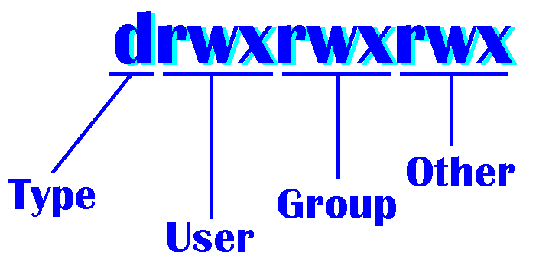

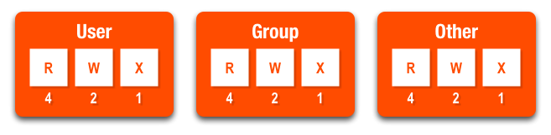

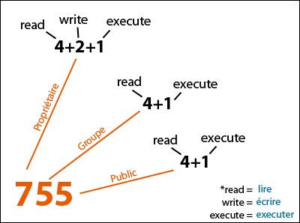

Q - How to set Permission ?

Ans : chmod 7 6 3 test

1. Give full permissions to all .

#chmod 777 test

1. Give permission to user only .

#chmod 700 test

1. Other way to assign permissions.

#chmod u+r test

#chmod g-w test

# chmod u+rw test

#chmod a+r test

Note: a = all ( u,g,o)